

Dr.M.G.R.Govt. Arts and Science College for Women,Villupram.

DEPARTMENT OF COMPUTER SCIENCE
PROJECT DOCUMENTATION
ON
Cricket Player Performance Tracking Application : CRICKSTATS
Submitted By (Group Members)
Name | Register Number
Kaviya P | 22324UCSC028
Kaviyarasi A (Team Lead) | 22324UCSC029
Keerthana S | 22324UCSC030
Logapriya K | 22324UCSC031
Lokeshwari V | 22324UCSC032

GUIDED BY:
Dr. N. Ashok Kumar, M.Sc., M.Phil., Ph.D.,
Assistant Professor
Department of Computer Science
Dr. M.G.R. Govt. Arts & Science College for Women
Villupuram – 605401, Tamil Nadu

GASC WVPM
Academic Year: 2026–2027

BONAFIDE CERTIFICATE
This is to certify that the project entitled “CRICKSTATS – Cricket Player Performance Tracking” is a bonafide work carried out by Ms. Kaviyarasi A bearing Roll Number: 22324UCSC029, submitted to the Department of Computer Science in partial fulfillment of the requirements for the award of the degree of Bachelor of Science (B.Sc.) in Computer Science during the Academic Year 2026–2027.
This project has been completed under the guidance of Mr. Ashok Kumar, Assistant Professor, Department of Computer Science, and has not been submitted previously for the award of any other degree or diploma.

Place: ___villupururam___________________
Date: ____26/9/2026__________________
Internal Guide | Head of the Department
Mr. Ashok Kumar | HOD
Assistant Professor | Department of Computer Science
Signature: __________ | Signature: __________

ACKNOWLEDGEMENT
We take immense pleasure in expressing our sincere gratitude to everyone who has guided and supported us throughout the successful completion of our project “CRICKSTATS – Cricket Player Performance Tracking.”
We express our heartfelt thanks to Mr. Ashok Kumar, Assistant Professor, Department of Computer Science, for his valuable guidance, constant encouragement, insightful suggestions, and continuous support during every stage of this project. His motivation and expert advice greatly helped us in completing the project successfully.
We extend our sincere gratitude to the Head of the Department of Computer Science for providing us with the opportunity, facilities, and academic environment necessary to carry out this project effectively.
We are grateful to all the faculty members of the Department of Computer Science for their valuable guidance, encouragement, and technical support throughout the development of this project. Their suggestions helped us improve the quality of our work.
We also wish to thank our college management for providing the infrastructure, computer laboratory, and Salesforce learning resources that enabled us to complete the project successfully.
Finally, we express our deepest gratitude to our parents, friends, and project team members for their unwavering support, cooperation, and encouragement. Their motivation and assistance, both directly and indirectly, played a significant role in the successful completion of this project.
Project Team
Department of Computer Science
Academic Year: 2026–2027

INDEX PAGE
1. Introduction
2. Ideation Phase
3. Requirement Analysis
4. Project Design
5. Project Planning & Scheduling
6. Project Development (Milestone 1–7)
7. Functional & Performance Testing
8. Advantages & Disadvantages
9. Conclusion
10. Future Scope
11. Appendix
User Story:
As a Salesforce Admin, I want to create a comprehensive player performance tracking application within Salesforce to capture and analyze detailed match-by-match information of cricket players. This application will include custom objects such as Player and Match Performance with carefully defined fields and relationships to ensure data integrity and accessibility. By leveraging master-detail and lookup relationships, the application will enable robust tracking of individual and team performances, facilitate insightful reporting and analytics, and support the overall management of player statistics, thereby enhancing strategic decision-making and player development initiatives.
1. INTRODUCTION
1.1 Project Overview
CRICKSTATS – Cricket Player Performance Tracking is a Salesforce-based application developed to manage, track, and analyze the performance of cricket players on a match-by-match basis. The project provides a centralized digital platform where player details and match performance records are stored in an organized manner. By using Salesforce custom objects, relationships, reports, dashboards, and automation tools, the application enables accurate maintenance of cricket statistics and supports data-driven decision-making.
The system is designed for coaches, team managers, sports analysts, and administrators who require reliable and real-time player information. Instead of maintaining records in multiple files or spreadsheets, CRICKSTATS stores all player and match data in a secure cloud environment, making it easily accessible and reducing the chances of data loss or manual errors.
1.2 Purpose of the Project
The primary purpose of this project is to digitize cricket player performance records and improve the overall management of player statistics. The application helps users record detailed batting, bowling, and fielding performances for every match, automatically calculates important performance metrics, and generates reports and dashboards for better analysis.
The project also aims to automate repetitive data management tasks using Salesforce Flows, ensuring accuracy, consistency, and efficiency. With centralized data storage and real-time analytics, CRICKSTATS supports player development, team planning, and strategic decision-making in cricket performance management.
1.3 Objectives
- To create a centralized database for cricket player records.
- To maintain match-by-match performance details accurately.
- To automate player statistics using Salesforce automation.
- To generate reports and dashboards for performance analysis.
- To improve decision-making through real-time cricket analytics.
2. IDEATION PHASE
The Ideation Phase is the process of identifying a real-world problem, understanding user needs, and developing an effective digital solution. The objective of this phase is to replace manual record management with a cloud-based system that improves accuracy, accessibility, and overall efficiency. The proposed application was designed by analyzing the requirements of coaches, team managers, sports analysts, and administrators who regularly manage cricket player information.
2.1 Problem Identification
In many sports organizations, player performance records are maintained using notebooks, spreadsheets, or separate files. This manual approach often results in duplicate records, calculation errors, delayed reporting, and difficulty in tracking player progress over multiple matches. As the amount of data increases, managing and analyzing player statistics becomes more challenging.
2.2 User Needs
The primary users of the system require a platform that can securely store player information, record match performances, generate accurate statistics, and provide meaningful reports for performance evaluation. They also need quick access to player data without depending on manual calculations.
2.3 Proposed Solution
The proposed solution is a cloud-based player performance tracking application developed using Salesforce. The system centralizes player and match data, automates statistical calculations, and generates reports and dashboards for better decision-making. This approach reduces manual work, improves data accuracy, and provides real-time access to player performance information.
The Ideation Phase establishes a clear foundation for designing and developing a reliable, scalable, and user-friendly sports performance management system.

3. REQUIREMENT ANALYSIS
3.1 Customer Journey Map
The requirement analysis phase focuses on understanding the complete journey of users while using the player performance tracking system. The process begins with the user logging into the application, followed by entering player information and recording match performance details. After the data is stored, reports and dashboards are generated automatically, allowing coaches, managers, and analysts to evaluate player performance and make informed decisions. This workflow ensures an organized and efficient management of cricket statistics.
Customer Journey:
Login → Enter Player Data → Record Match Performance → Generate Reports → Analyze Results → Decision Making
3.2 Solution Requirements
Functional Requirements
The application provides several core functionalities required for effective player management. It allows user registration of players, match performance entry, automatic report creation, interactive dashboard generation, and workflow automation through Salesforce Flows. These features ensure that player records are maintained accurately and can be analyzed efficiently.
Non-Functional Requirements
The system is designed to be user-friendly, secure, reliable, and highly available. It provides an intuitive interface for coaches and managers, role-based access for data protection, accurate cloud-based data storage, fast report generation, and continuous availability for users. The application is also scalable, enabling future expansion to support multiple teams, leagues, and a larger volume of player records without affecting performance.
3.3 Technology Stack
The project is developed using Salesforce Lightning as the frontend platform, Custom Objects for data management, Salesforce Flows for automation, and Reports & Dashboards for analytics. Salesforce Cloud serves as the database, providing secure storage and real-time accessibility of cricket performance data.
The requirement analysis confirms that the proposed system satisfies both user needs and technical requirements, providing an efficient solution for digital cricket player performance management.
3.4 Data Flow Diagram
Data Flow
User → Salesforce UI → Player Object → Match Performance → Reports → Dashboard

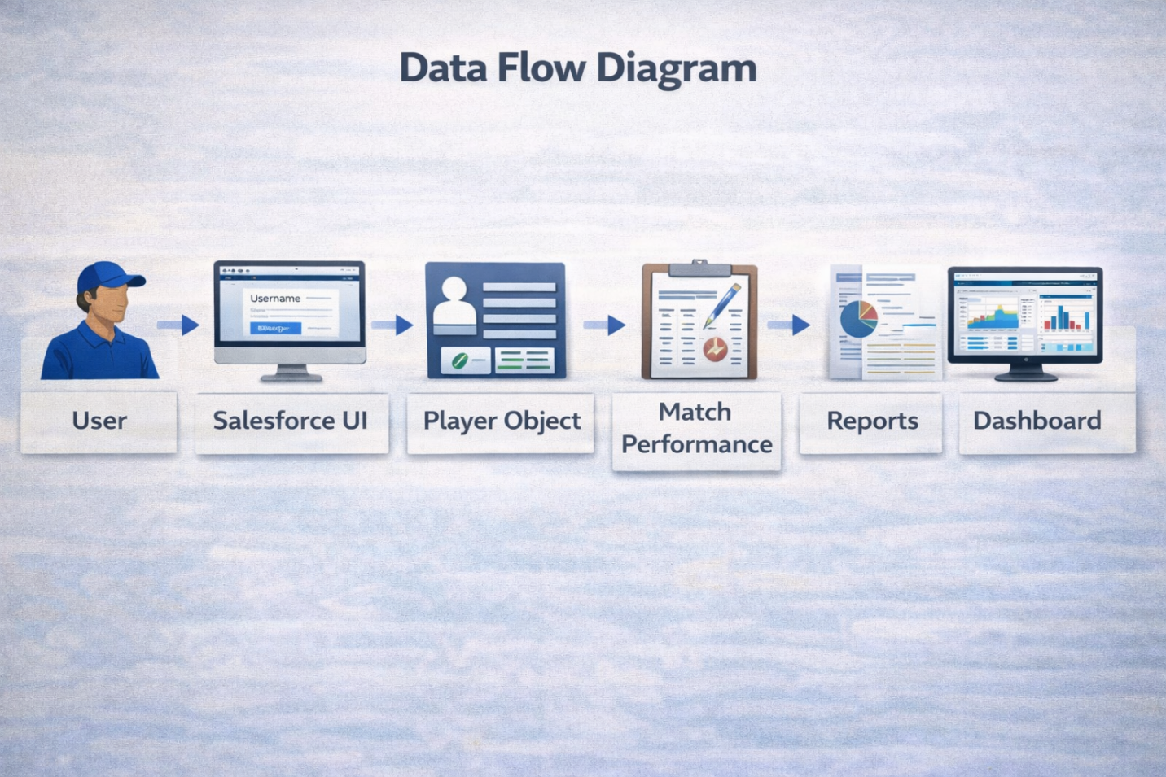

3.5 Technology Stack
Layer | Technology
Frontend | Salesforce Lightning
Analytics | Reports & Dashboards
Automation | Salesforce Flows
Backend | Salesforce Objects
Database | Salesforce Cloud

4. PROJECT DESIGN PHASE
4.1 Problem–Solution Fit
The CRICKSTATS system effectively addresses the key challenges faced in traditional cricket performance management. Earlier, most player and match data were maintained using manual records, which were time-consuming and prone to errors. This issue has been resolved by implementing an automated system through Salesforce, which ensures accurate and efficient data entry and management. The problem of data loss, caused by improper storage and lack of backups, is overcome by using secure cloud storage that safely stores all information and allows easy retrieval. Poor analysis of player performance, due to scattered and unorganized data, is addressed through interactive dashboards that present clear visual insights and reports. Additionally, delays in accessing performance information and generating reports are eliminated by providing real-time reporting features, enabling users to make faster and more informed decisions. Thus, CRICKSTATS successfully bridges the gap between existing problems and modern technological solutions.

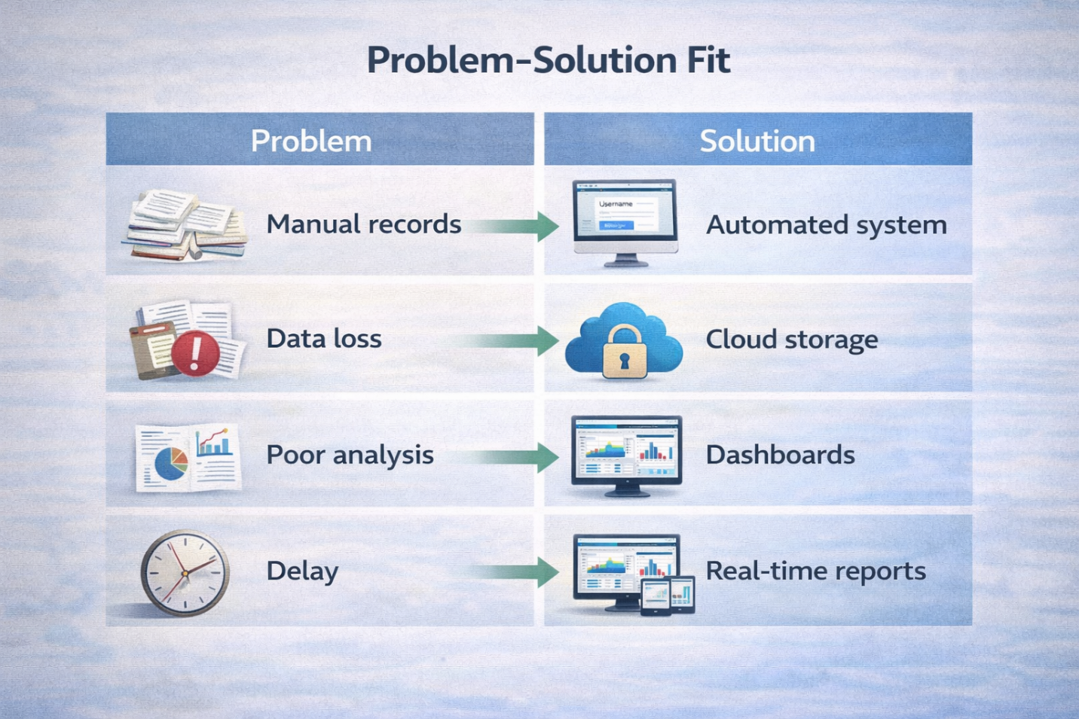

4.2 Proposed Solution
Description
CRICKSTATS provides:
- Custom objects (Player, Match Performance)
- Master-detail relationships
- Roll-up summaries
- Lightning App
- Automated flows
- Interactive dashboards
Key Features
- Centralized database
- Live statistics
- Secure access
- Scalable design
- Easy reporting

4.3 Solution Architecture
Architecture Layers
- Presentation Layer (Lightning UI)
- Application Layer (Flows, Logic)
- Data Layer (Objects)
- Analytics Layer (Reports)
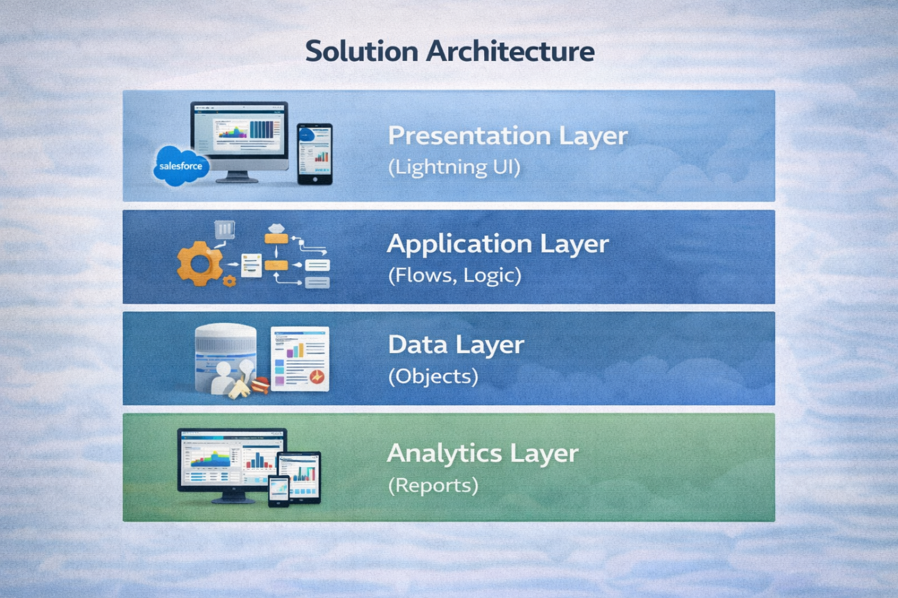
The Solution Architecture represents the overall design of the player performance tracking system. It is divided into four layers to ensure efficient data management, automation, and reporting. Each layer performs a specific function while working together to provide a complete Salesforce-based solution.
The Presentation Layer provides the Lightning user interface for entering and viewing player records. The Application Layer manages business logic and automated workflows using Salesforce Flows. The Data Layer stores player and match information through custom objects and relationships. Finally, the Analytics Layer generates reports and dashboards that help coaches and managers analyze player performance and make better decisions. This layered architecture improves accuracy, scalability, and the overall efficiency of the system.

5. PROJECT PLANNING & SCHEDULING
5.1 Project Planning
- Agile-based execution
- Object creation → automation → reporting
- Sprint-wise development
Product Backlog, Sprint Schedule, and Estimation
Use the below template to create product backlog and sprint schedule
Sprint | Functional Requirement (Epic) | User Story Number | User Story / Task | Story Points | Priority | Team Members
Sprint-1 | Developer Setup | USN-1 | As an admin, I want to create a Salesforce developer account so that I can configure and deploy the CRICKSTATS system. | 1 | High | Member1
Sprint-1 | Data Modeling | USN-2 | As an admin, I want to create Player and Match Performance objects so that player and match data can be stored systematically. | 3 | High | Member2
Sprint-2 | Navigation | USN-3 | As a user, I want separate tabs for each object so that I can easily navigate and manage records within the application. | 3 | High | Member3
Sprint-2 | UI Design | USN-4 | As a coach, I want a dedicated Lightning App so that all performance tracking features are accessible from one dashboard. | 3 | High | Member4
Sprint-2 | Data Structure | USN-5 | As an admin, I want to create player and match fields so that complete performance details can be captured accurately. | 5 | Medium | Member1
Sprint-2 | Data Structure | USN-6 | As a user, I want customized page layouts so that only relevant fields are displayed during data entry. | 5 | High | Member2
Sprint-2 | Automation | USN-7 | As a system, I want to validate player and match inputs so that incorrect data entries are prevented. | 3 | High | Member4
Sprint-3 | Automation | USN-8 | As a system, I want automated flows to update player statistics so that performance data remains accurate. | 5 | High | Member1

Project Tracker, Velocity & Burndown Chart
Sprint | Total Story Points | Duration | Sprint Start Date | Sprint End Date (Planned) | Story Points Completed (as on Planned End Date) | Sprint Release Date (Actual)
Sprint-1 | 20 | 6 Days | 01 sept 2026 | 06 sept 2026 | 20 | 06 sept 2026
Sprint-2 | 20 | 6 Days | 08 sept 2026 | 13 sept 2026 |  | 13 sept 2026
Sprint-3 | 20 | 6 Days | 15 sept 2026 | 20 sept 2026 |  | 20 sept 2026
Sprint-4 | 20 | 6 Days | 22 sept 2026 | 27 sept 2026 |  | 27 sept 2026

6. PROJECT DEVELOPMENT PHASE
The Project Development Phase describes the practical implementation of the CRICKSTATS NM.pdf application in Salesforce. The project was developed using an Agile approach, where each milestone was completed step by step to build a fully functional player performance tracking system. During this phase, custom objects, relationships, automation, reports, and dashboards were created to manage cricket player statistics efficiently.
Project Flow
- Milestone 1: Creation of Developer Account
- Milestone 2: Object Creation
- Milestone 3: Tabs
- Milestone 4: The Lightning App
- Milestone 5: Fields & Relationships
- Milestone 6: Roll-up Summary
- Milestone 7: Flows
Implementation Overview
The development begins with creating a Salesforce Developer Account and configuring the development environment. Next, the Player and Match Performance custom objects are created, followed by custom tabs and the CRICKSTATS Lightning App for easy navigation. Fields, relationships, and roll-up summary fields are then implemented to calculate player statistics automatically. Finally, Salesforce Screen Flows are developed to display players based on the selected team and provide an interactive user experience. This systematic implementation results in a secure, centralized, and efficient cricket player performance tracking application.

Implementation
Milestone 1 - Salesforce developer account creation :
Activity 1: Creating Developer Account:

This screenshot shows the Salesforce Developer account registration page. The required user information is entered to create a new developer account. This account provides the development environment for building the player performance tracking application.

Activity 2: Account Activation :
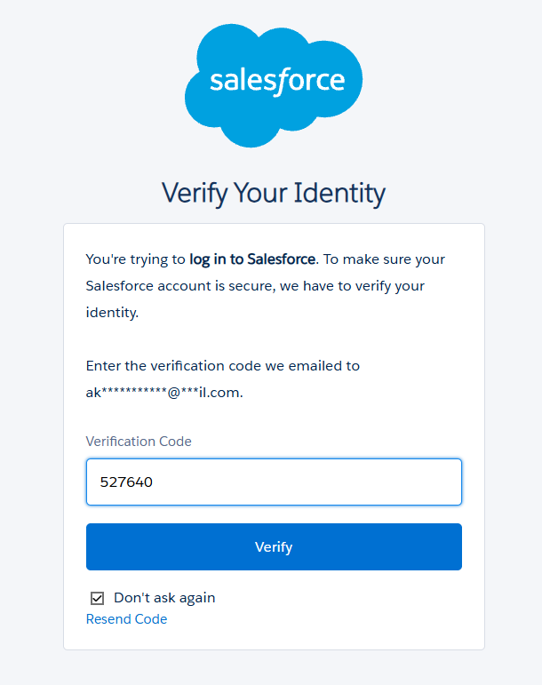
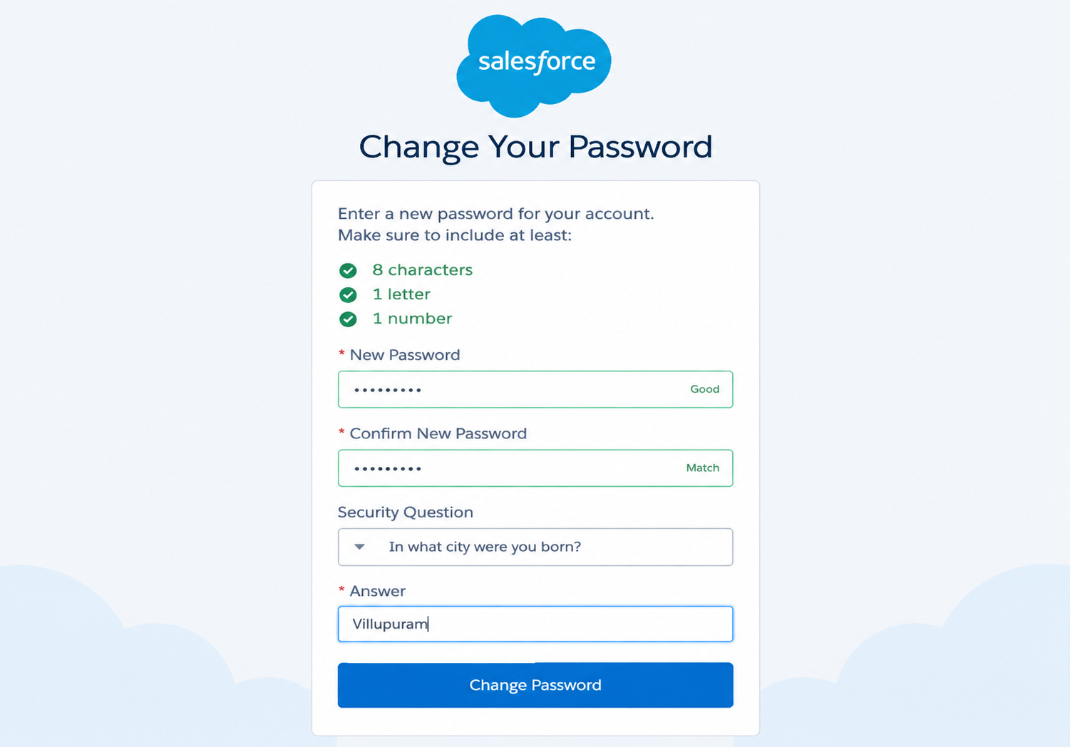
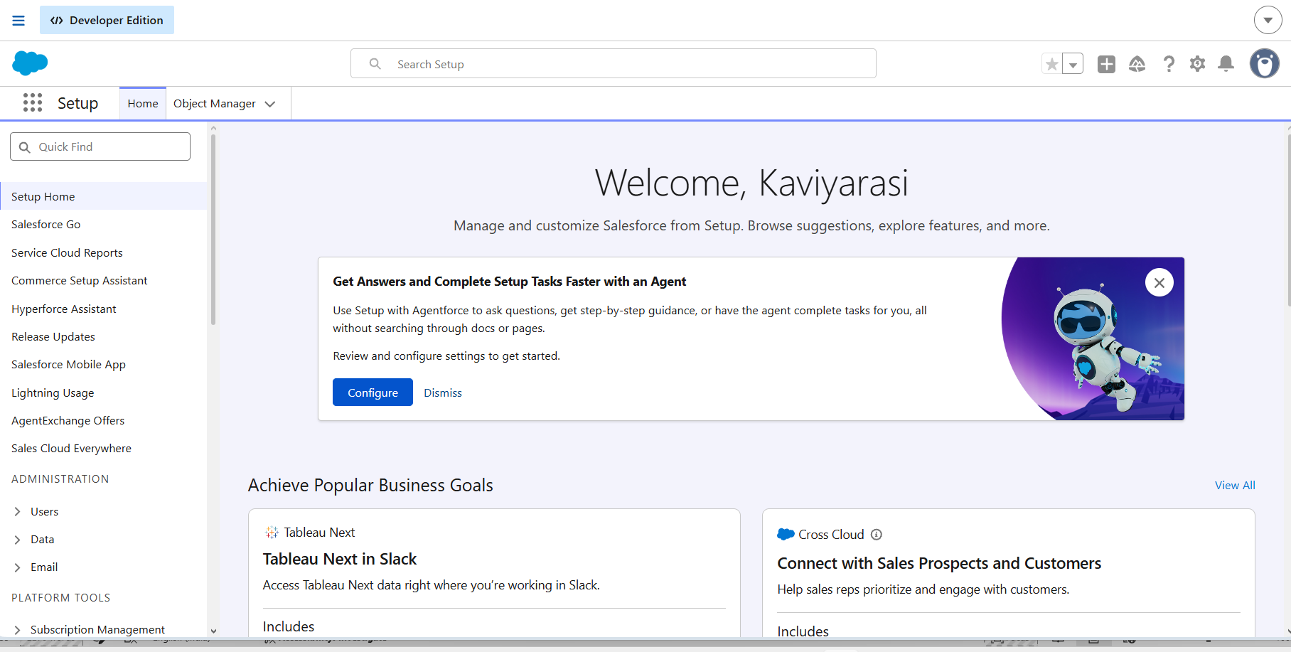
Verify Account
This screenshot shows the Salesforce Verify Account page. The user verifies the registered email address to activate the developer account. This completes the email verification process.
Reset Password
This screenshot shows the Reset Password page in Salesforce. The user creates a new password and sets a security question and answer. The account is activated after clicking Change Password.
Salesforce Home page
This screenshot shows the Salesforce Home page after successful login. It provides access to the Salesforce development environment and its setup features. The user can now begin building the application.

Milestone 2 - Object Creation
Activity 1 : Player Object
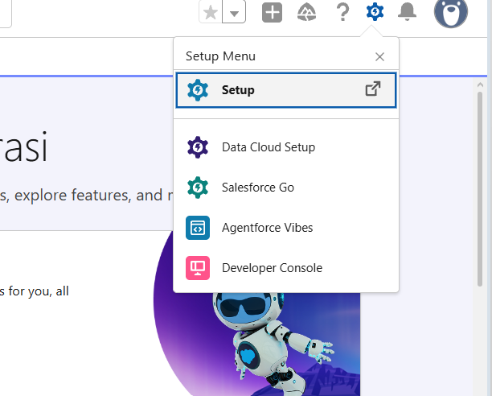
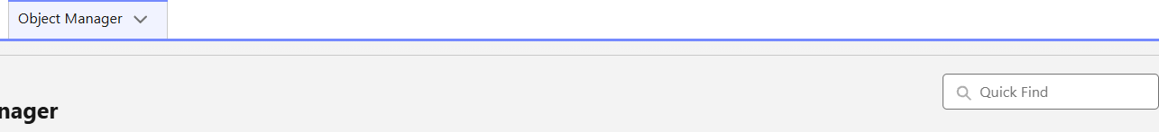

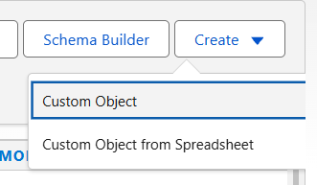
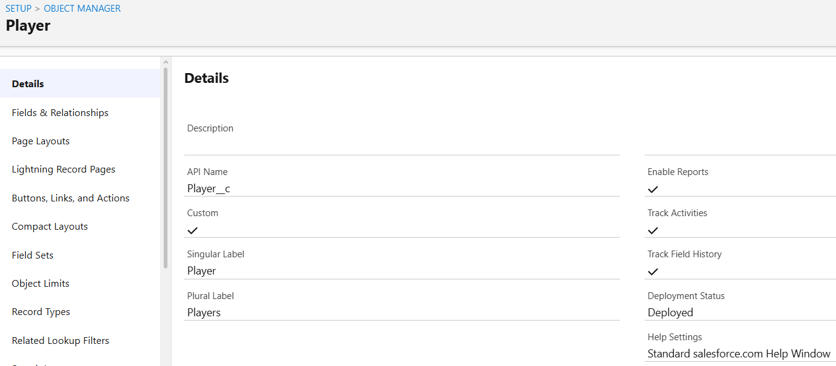 This screenshot shows the creation of the Player custom object in Salesforce. The Player object is used to store the personal and performance details of each cricket player.

Activity 2 : Match Performance Object
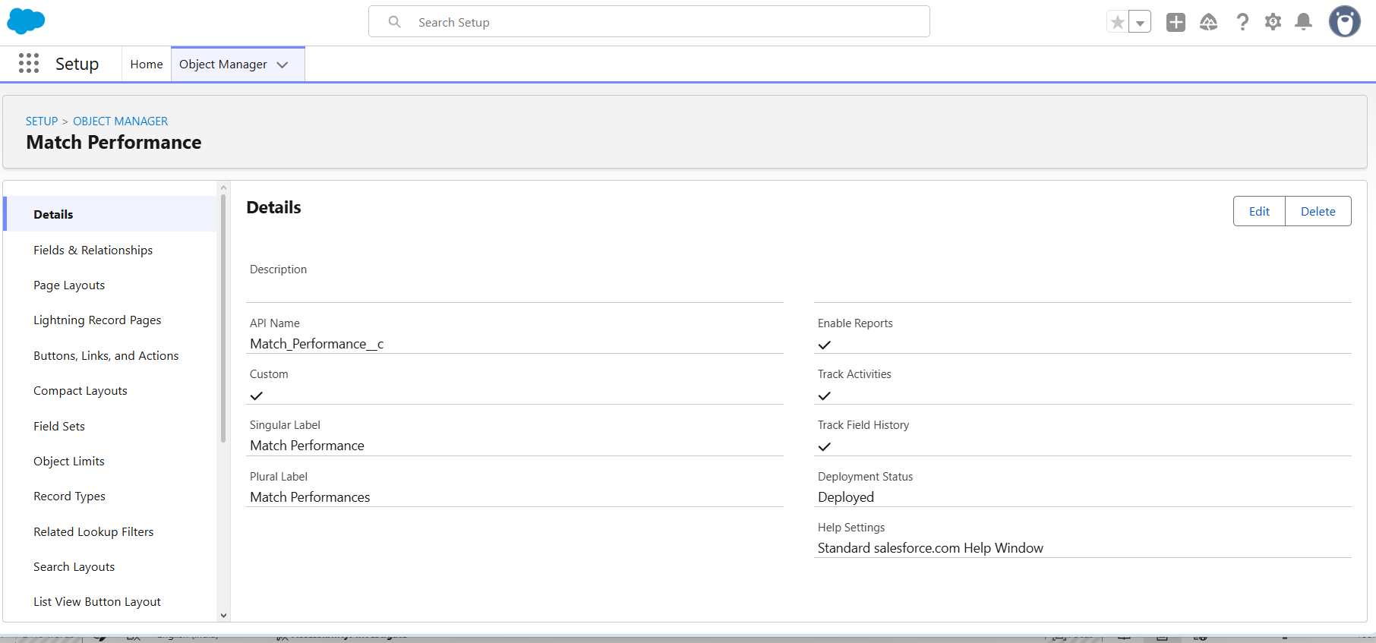
This screenshot shows the creation of the Match Performance custom object in Salesforce. It is used to store the batting, bowling, and fielding performance details of players for each match.
Milestone 3 - Tabs
Activity 1 : Custom tabs creation
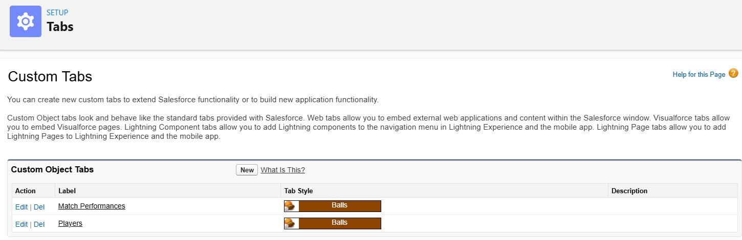
This screenshot shows the Custom Tabs page in Salesforce Setup. The Players and Match Performances tabs are created to provide easy navigation within the application.

Milestone 4 - The Lightning App
Activity 1 : Create a lightning app
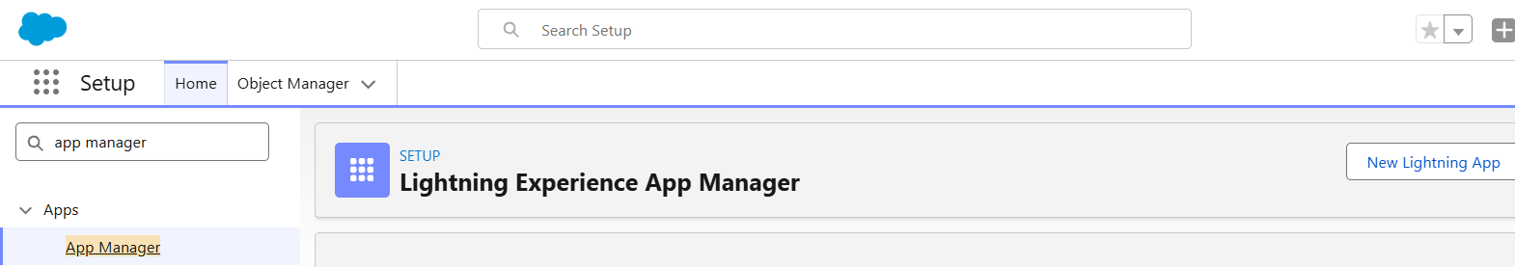
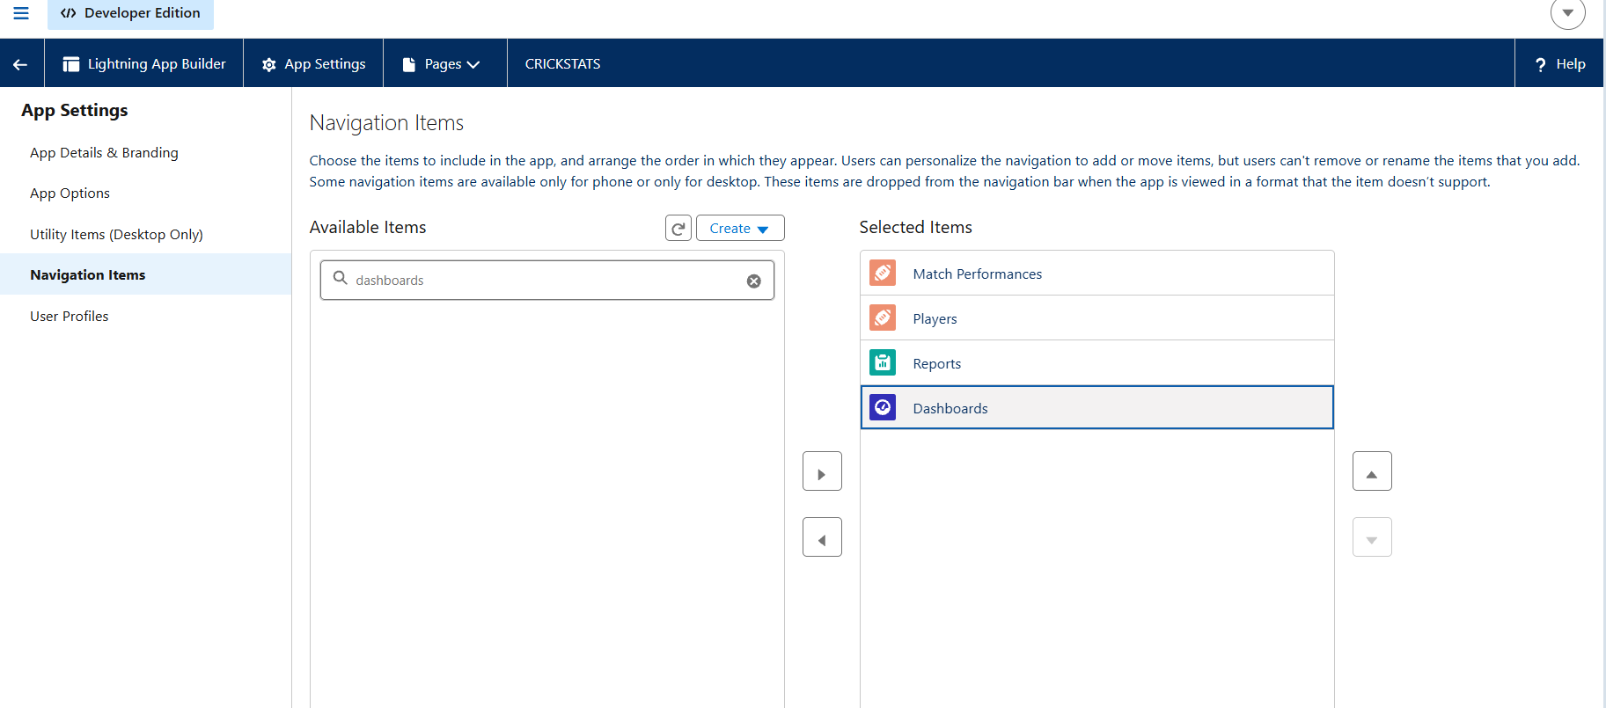
This screenshot shows the creation of the Lightning App in Salesforce. The app provides a centralized workspace that includes Players, Match Performances, Reports, and Dashboards for easy navigation.
Milestone 5 : Fields & Relationships
Activity 1 : Create Custom fields for Player object
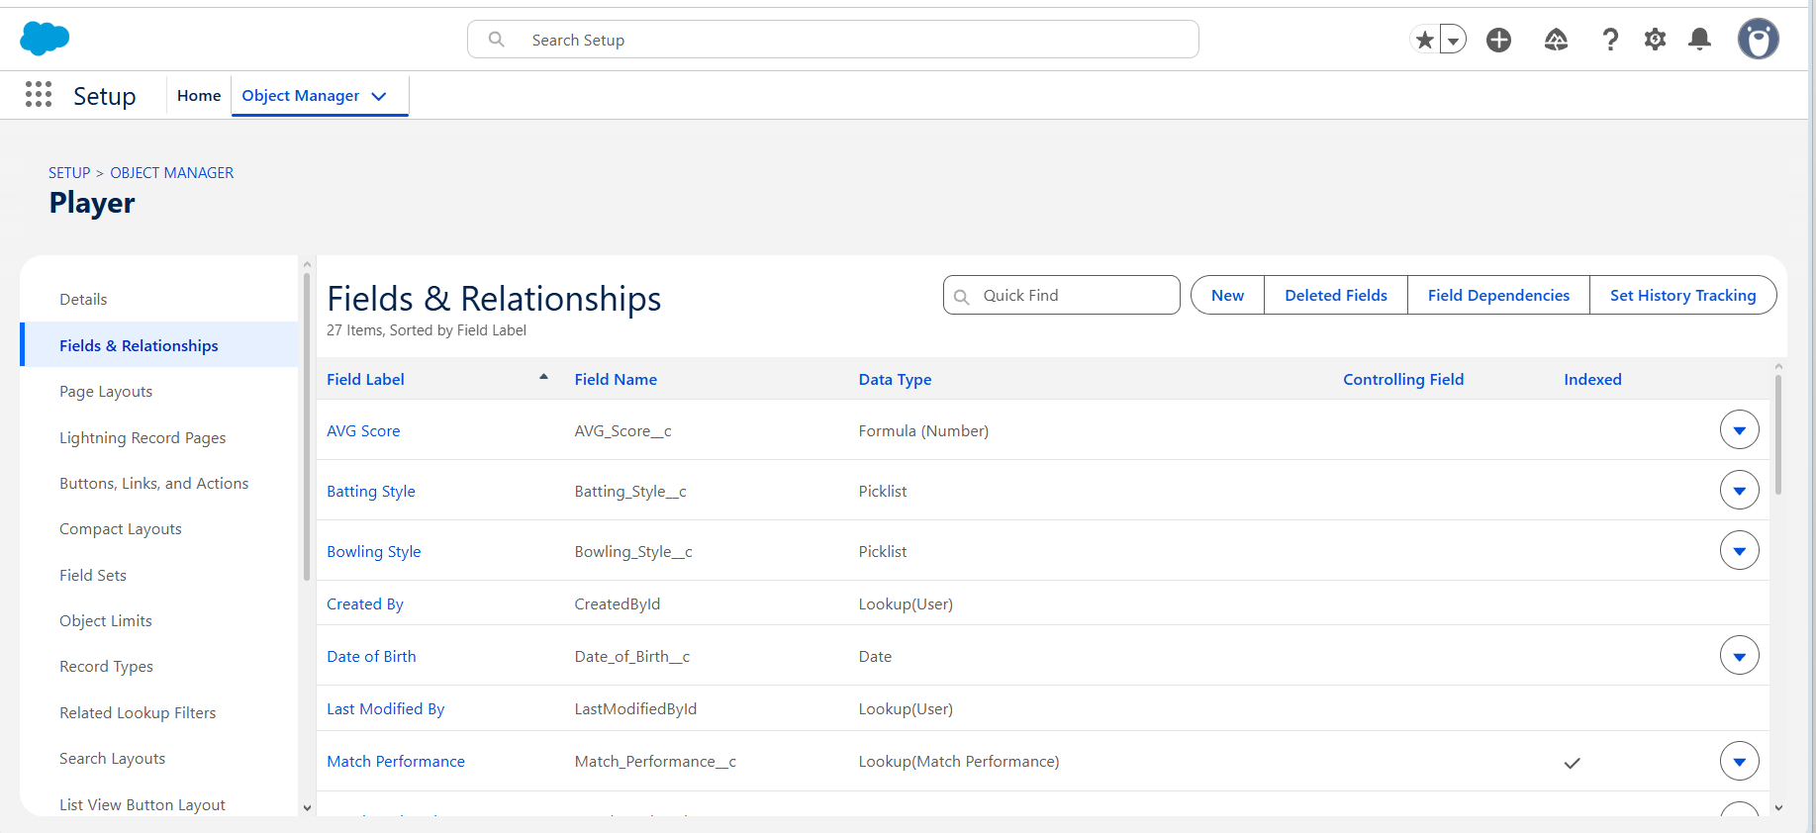
This screenshot shows the creation of custom fields for the Player object in Salesforce. The custom fields are used to store player information such as name, role, batting style, bowling style, nationality, and team.
Activity 2 : Create Custom fields for Match Performance object
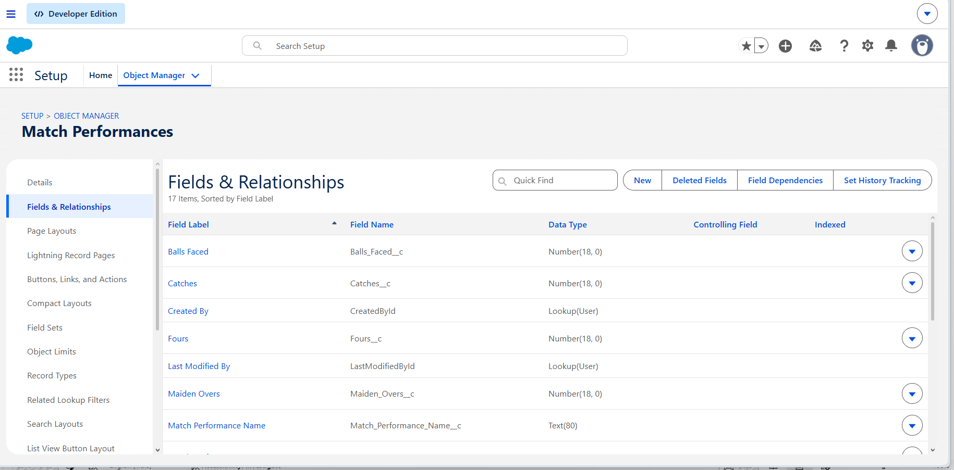
This screenshot shows the creation of custom fields for the Match Performance object in Salesforce. These fields are used to record the batting, bowling, and fielding performance details of players for each match.
Milestone 6 : Roll-up Summary
Activity 1 : Create Roll-up Summary for Player object
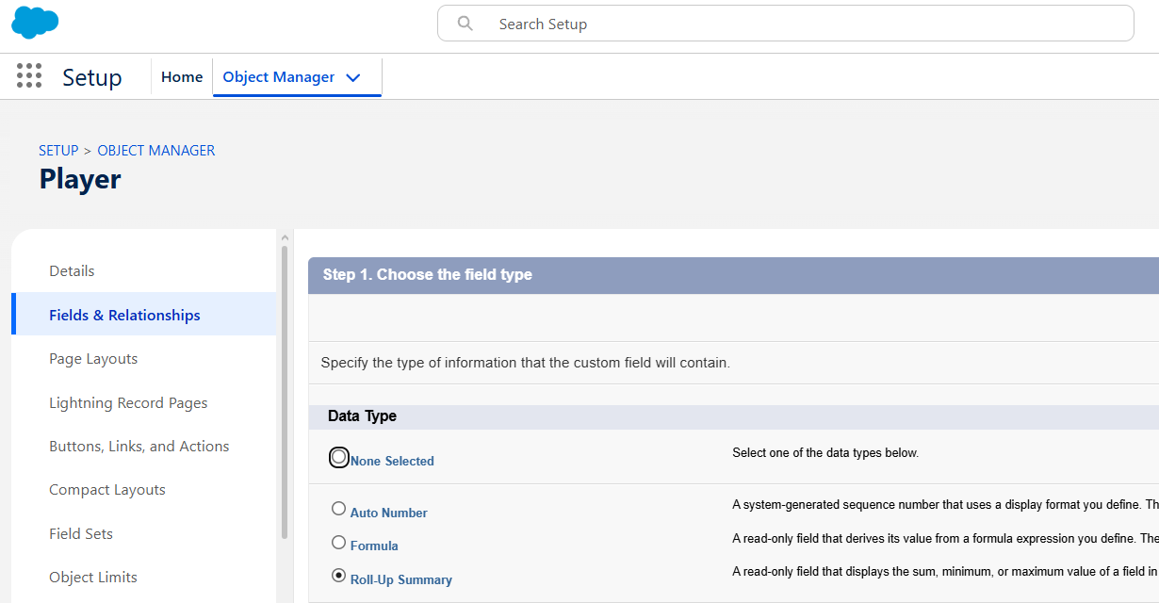

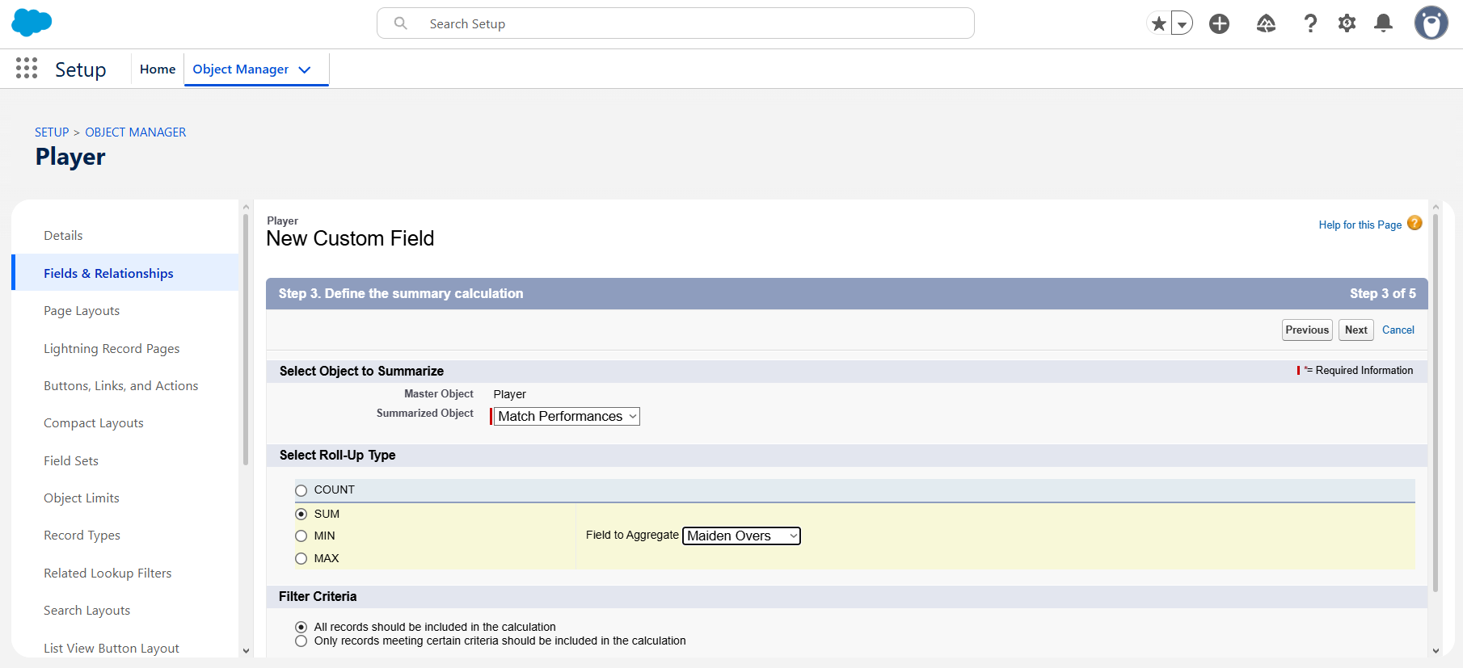
Filter Criteria : All records should be included in the calculation.
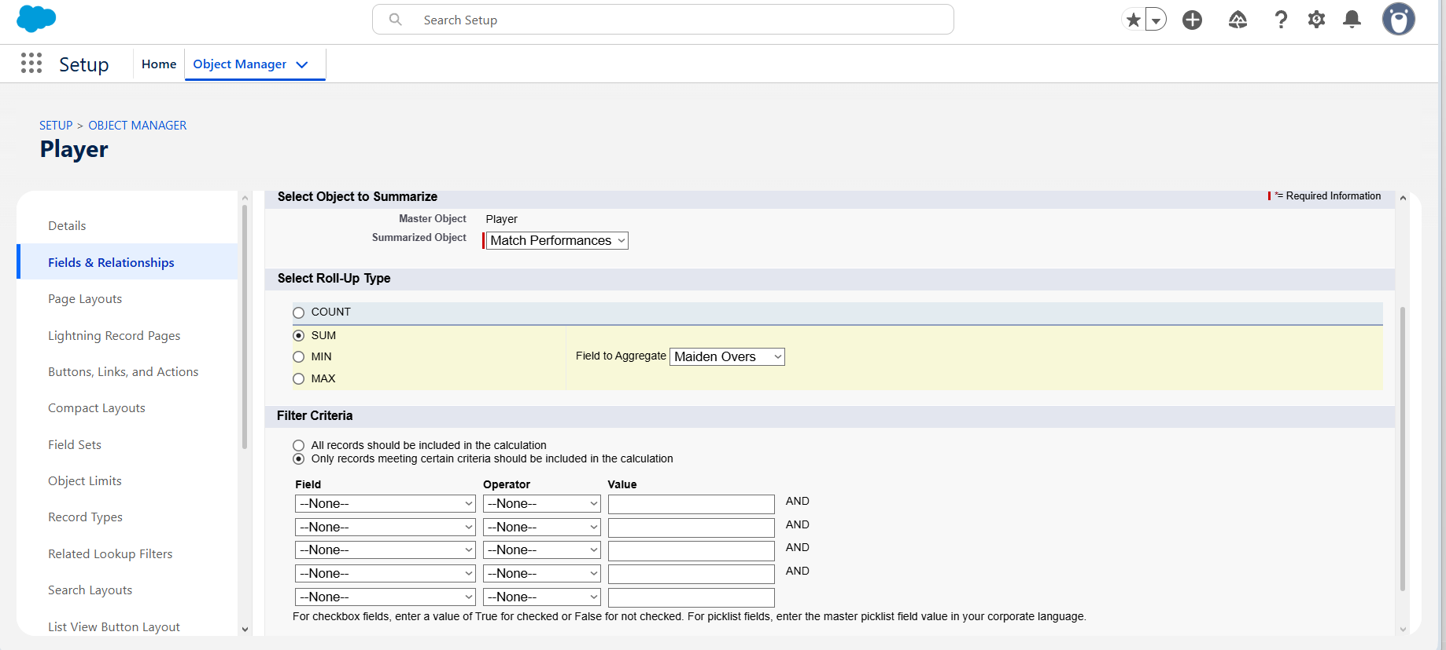
Filter Criteria : Only records meeting certain criteria should be included in the calculation.
This screenshot shows the creation of Roll-up Summary fields for the Player object in Salesforce. The roll-up summary automatically calculates values such as matches played, total runs, wickets, catches, and other player performance statistics.

Milestone 7 : Flows
Activity 1 : Screen Flow
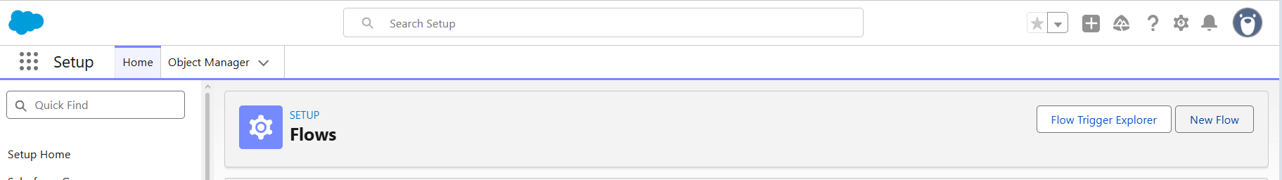
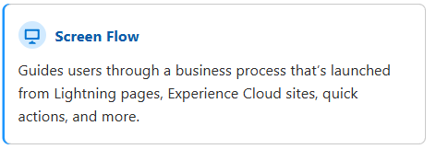
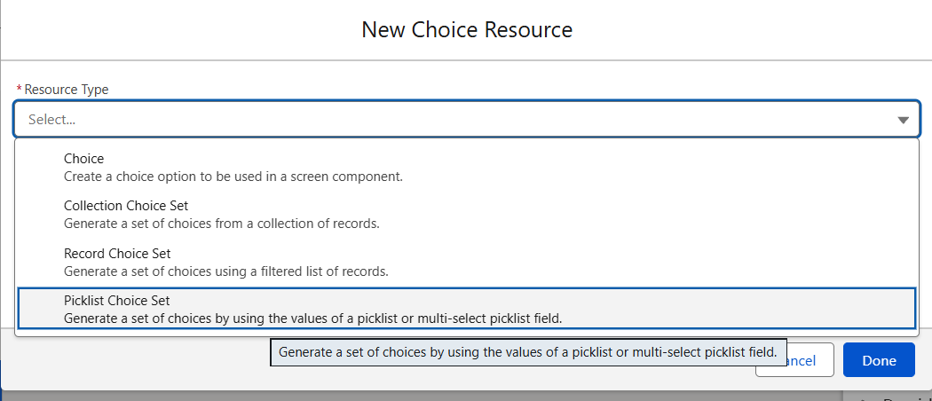
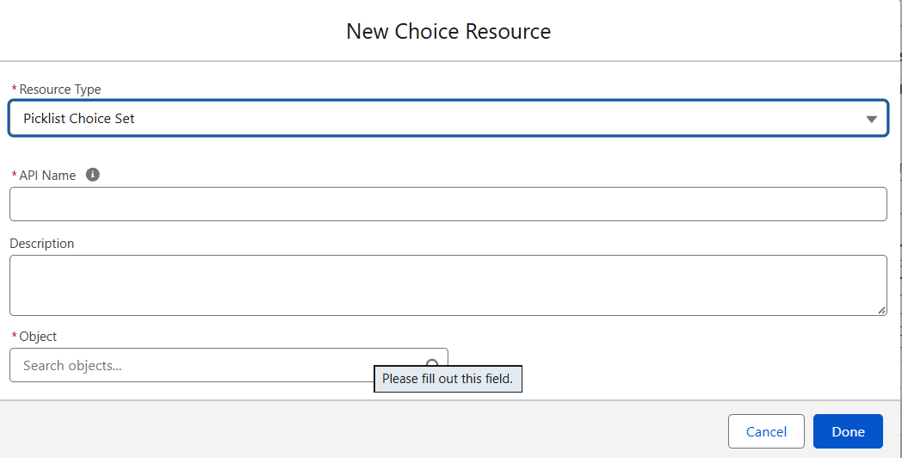
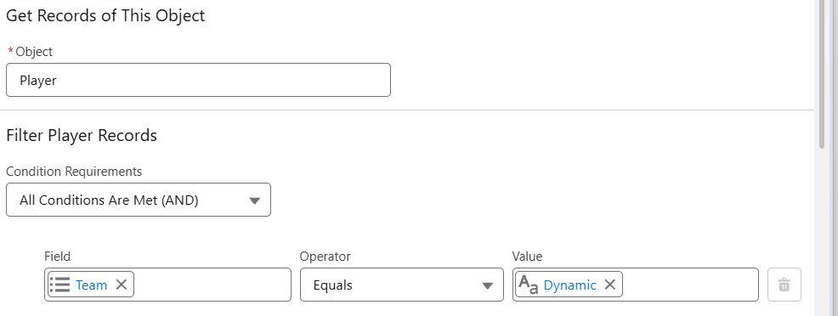

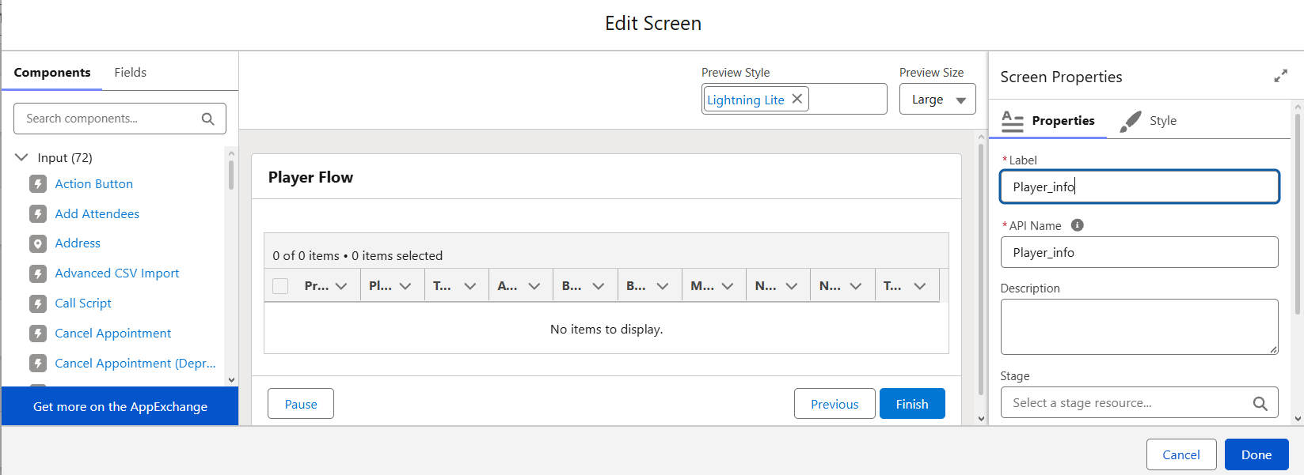

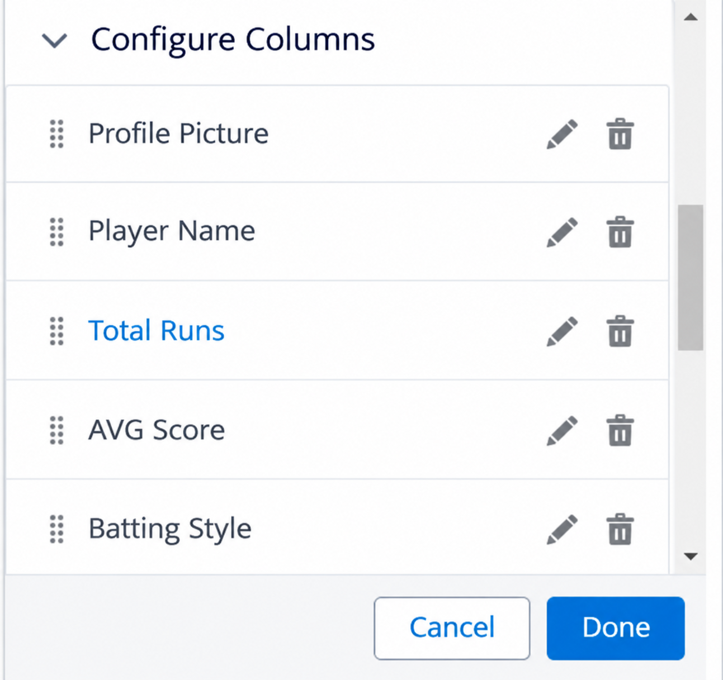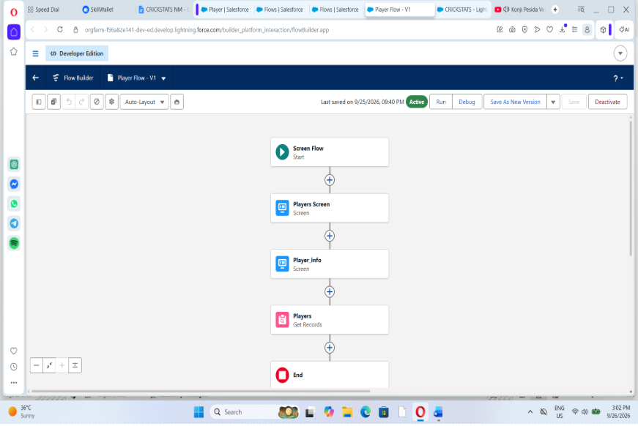

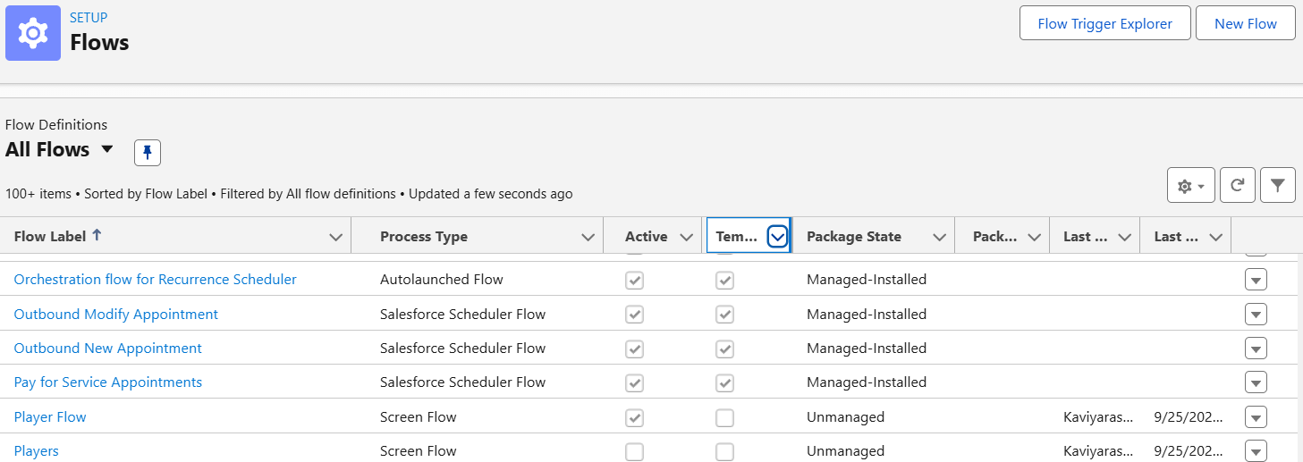

This screenshot shows the creation of a Screen Flow in Salesforce. The flow allows users to select a team and automatically displays the corresponding items.
Activity 2 : Flow on Home Page
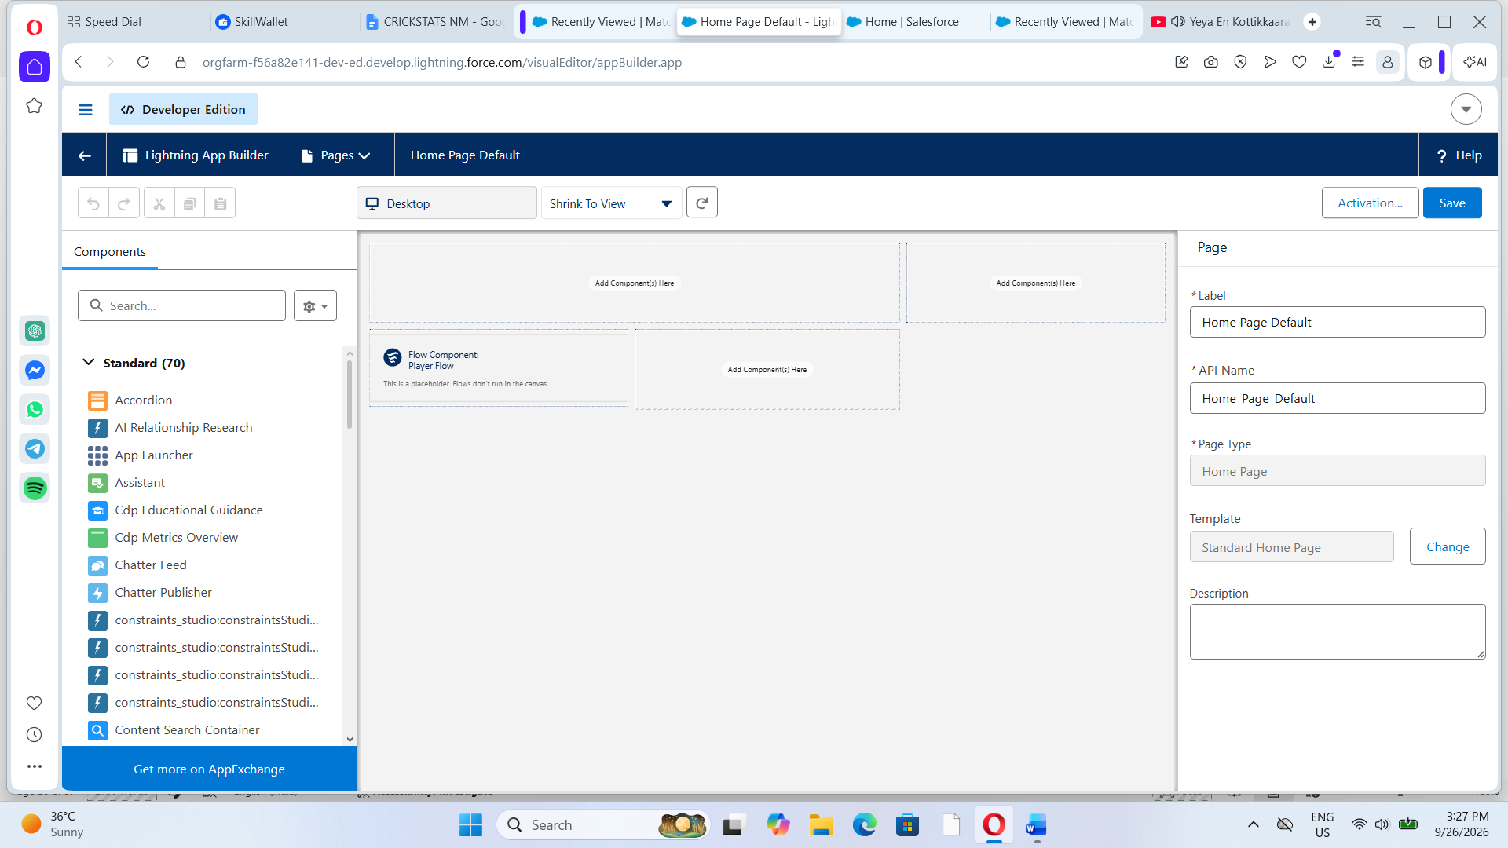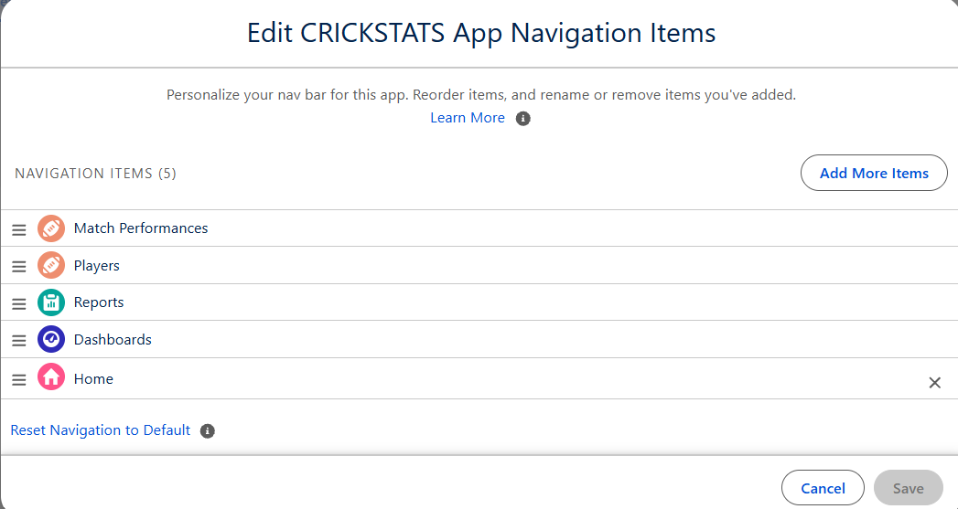

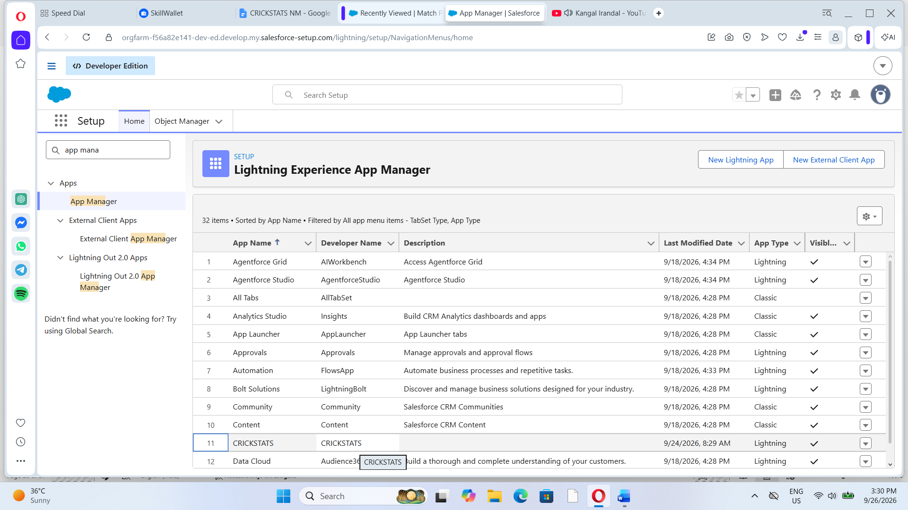
This screenshot shows the Player Flow added to the Home Page of the Lightning App. The flow is activated as the default home component, allowing users to view player information directly from the home page.

7.FUNCTIONAL & PERFORMANCE TESTING
During the testing phase, screenshots were captured from the Salesforce Lightning user interface to verify the correct functioning of all implemented features in the CRICKSTATS system. These include record creation for Player and Match Performance objects; validation rule checks for mandatory fields, score limits, and input constraints; verification of record type behavior for Domestic and International match categories; and flow execution for automatic updating of player statistics and data consistency. The functionality of roll-up summary fields was also tested to ensure accurate calculation of total runs, wickets, averages, and performance metrics.
In addition, system performance was evaluated by monitoring response time during data entry, report generation, and dashboard loading. The application was tested under multiple user interactions to ensure stable performance without delays. Screenshots of generated reports and interactive dashboards were documented to confirm accurate data visualization, real-time updates, and reliable performance tracking. These testing activities ensured that the CRICKSTATS platform met both functional and performance requirements and was ready for deployment.
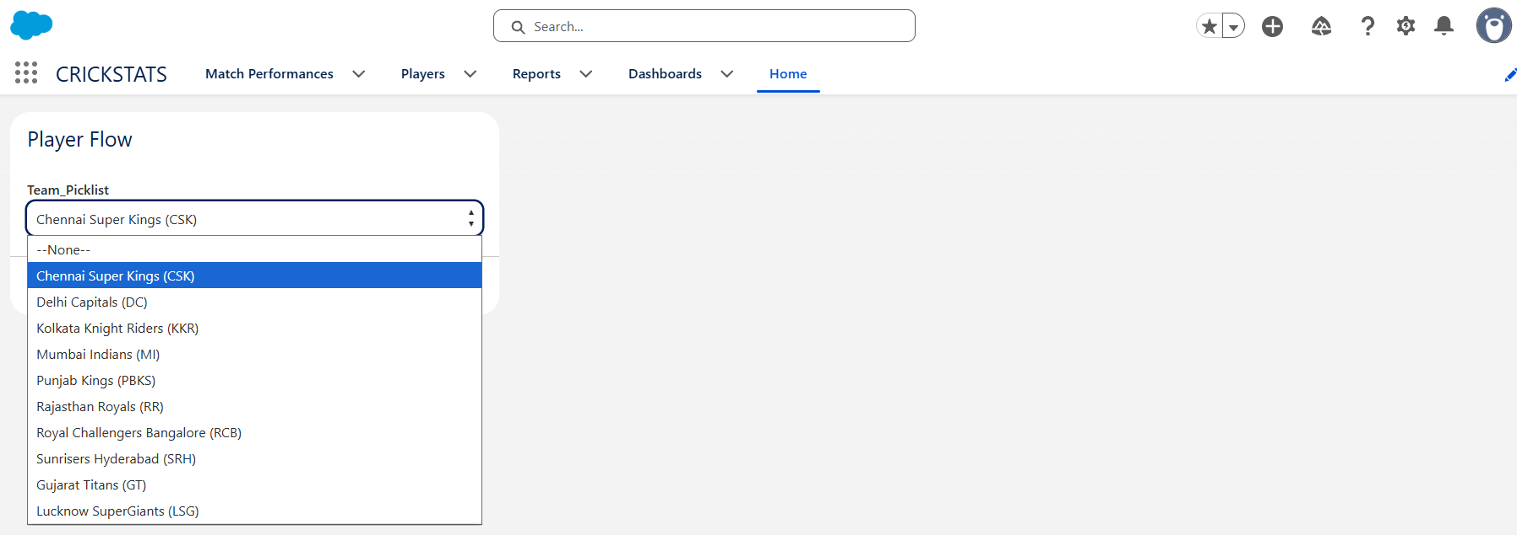

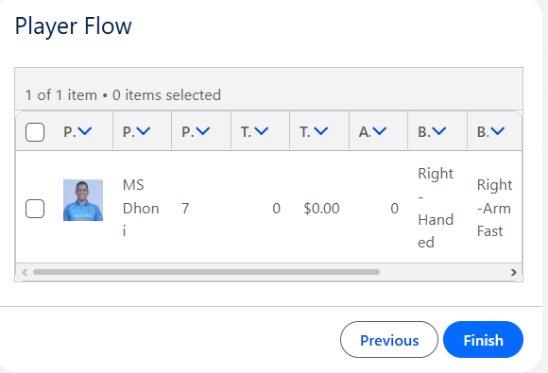
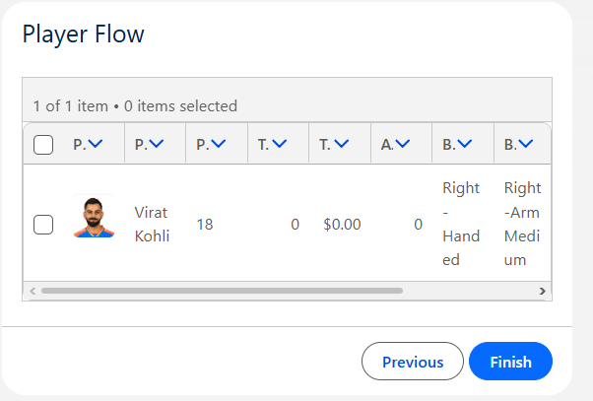
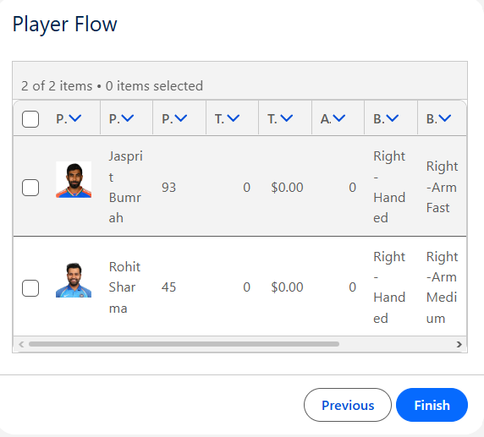
The Functional and Performance Testing phase was carried out to verify that all features of the application work correctly and produce accurate results. Player records, match performance details, roll-up summaries, screen flows, reports, and dashboards were tested to ensure proper functionality. The application was also evaluated for response time, data consistency, and real-time performance updates.
Testing Result
The application successfully created and managed player records, automatically updated performance statistics through roll-up summaries, executed screen flows correctly, and generated accurate reports and dashboards. The system performed efficiently without delays, confirming that both the functional and performance requirements were satisfied.

8. ADVANTAGES & DISADVANTAGES
Advantages
- Centralized system
- Real-time analytics
- Secure platform
- Scalable design
- Reduced manual work
Disadvantages
- Requires Salesforce license
- Internet dependency
- Limited offline access
9. Conclusion:
CRICKSTATS successfully implements a cloud-based cricket performance tracking system using Salesforce. The system automates data management, improves reporting accuracy, and supports informed decision-making.
The project demonstrates practical application of SDLC, Agile methodology, and CRM-based development.
10. FUTURE SCOPE
- Mobile application integration
- AI-based performance prediction
- Video analysis integration
- Player ranking system
- Public statistics portal
- Multi-league support
11. APPENDIX
Appendix A – Salesforce Objects & Fields
This appendix contains the list of Salesforce objects and custom fields used in the project.
Appendix B – Manual Match Statistics
This appendix includes the sample player and match statistics used for testing the application.
Appendix C – Flow Configurations
This appendix contains the flow configuration details used to implement the player performance tracking process.

THANK YOU

